Quantum (5 5 12) Silicon Nanowire 300K MOSFET
D. L. Kendall^{a,b}*, F. J. De la Hidalga-Wª, R .R. Rodríquez-Mª, M. Castro-Lª
A. Torres-Jª, W. Calleja-Aª, E. Meza Prieto^{a,c}, M. Landa-Vª, C. Zúñiga-Iª
R. Murphy-Aª, N. Carlos-Rª, I. Juárez-Rª, M. Kendallª

ª Instituto Nacional de Astrofisica, Optica, y Electronica (INAOE), Puebla, Mexico
^{b} Center for High Technology Materials (CHTM)
University of New Mexico, Albuquerque, NM 87106, USA
^{c} Present address: Universidad Autónoma de Ciudad Juárez, Chihuahua, Mexico
∗Contact Author: e-mail: donk@chtm.unm.edu ; phone: 505-299-5903

A nanowire (NW) device in parallel with a normal nMOSFET is fabricated with a poly-Si planar CMOS process on (5 5 12)Si. With a unit cell of 5.35 nm, this plane has the largest stable atomically flat Si surface. When output current Isd flows from source S to drain D along <110>, the device has 15 positive spikes at integer multiples of 154 mV, all at 300K and zero magnetic field. Ids has only 9 positive and 2 negative spikes. The positive spikes in Isd and Ids are due to parabolic confinement of elongated q-dots in the NWs near D. Both Isd and Ids show missing spikes and one-dimensional artificial atom behavior. The negative spikes appear to be Kronig-Penney effects on the NWs. The NWs and q-dots have estimated widths near 2 nm and Line Edge Roughness (LER) less than 0.1 nm due to the crystal-lattice precision of the surface.

Perspective and Introduction

There have recently been a number of discussions of the future of CMOS and other modern nanoelectronic devices when the smallest meaningful dimensions (SMDs) are reduced to the “single-digit” true nanometer scale below 10 nm. For example, significant attention has been paid to spin-based logic which predicts that up and down spins can move in an electric field in opposite directions along opposite edges of a nanowire, sometimes even in a zero magnetic field (1). A related example involves the storage and dissociation of excitons in parallel chains of semiconducting polymers (2). Quantum dots (q-dots) also have a wide range of highly unusual properties (3). Another surprising effect involves a circuit that results in the violation of Kirchoff’s laws where series resistors no longer add to each other (4). All of the above are generally only observed within a few degrees of absolute zero, and they typically occur only when one or more of the device dimensions are of the same magnitude as interatomic distances or the electron wavelength (5). We discuss here a room temperature nanowire device made with standard CMOS technology that has several perplexing anomalies that appear to fall into one or more of the above categories. However, in this work we limit our working model to well known quantum effects involving parabolic confinement of elongated Si q-dots (6), the electron reflected branch of the Kronig-Penney model (6), and evidence for the existence of one dimensional (1D) or two dimensional (2D) artificial atoms (7).

High Index Silicon Structure and Previous Nanometer Scale MOSFET Efforts

Scanning Tunneling Microscope (STM) images of several (hhk), or “(11X)”, high index Si surfaces can be seen in (8,9). The relevant images for this work of well aligned and slightly misaligned (5 5 12)Si are shown in Fig. 1 from (8) and Fig. 2 from (10), respectively. The (5 5 12) and (114) surfaces are the only well ordered and atomically flat high index crystal planes of Si that have a well defined linear texture similar to that shown in Fig. 1. We often informally call the (5 5 12) the (1 1 2.4) plane, which shows that it resides about halfway between the (112) and the (113) planes. Electron mobilities in 8 different surface directions and implant profiles on (5 5 12), (114), and (100) are reported by Castro, et al. in (11), and surface state densities and oxidation data on these planes are reported by Rodriquez, et al. in (12). Seminal work that was similar to ours was done in 1977 using the natural surface texture of the high index (118) to fabricate Si nMOSFETs (13). This showed extremely small conductance perturbations in the transfer curves at 1.5K. For a detailed review of this device, see (14). It is now known that the (118) is not a very well ordered surface of Si (8). Over a decade later, somewhat unstable but quite regular periodic conductance oscillations on (100) Si near 0.1K were observed in nMOSFETs made with 70 nm lithography (15). The above lithography-based approaches (13,15) appear to have been adversely affected by surface roughness and excessive Line Edge Roughness (LER). Finally, small irregular conductance variations were recently reported at 300K at very low drain voltages of 100 µV at Vg < 1V on a trigate SOI nMOSFET (16).

(5 5 12) MOSFETs from 300K Down to 77K and Critical Experimental Observations. Our devices on (001), (114), and the ones reported here on the (5 5 12), were fabricated at INAOE with a complete hydrogen-passivated CMOS process using standard poly-Si gate technology. The nMOSFETs had a Length to Width ratio L/W of 10 µm/10 µm and a gate oxide thickness of 70 nm. We measured the device properties of a total of 12 packaged chips from 2 different (5 5 12) wafers in a cryostat from 300K down to 77K (17) with the HP 4156 Parameter Analyzer with Vd-increments of 0.02V. This increment of ± 0.02V is also the uncertainty of the positions of the spike voltage maxima. The actual spike half-widths are probably much narrower than shown in Fig. 3. They may be even narrower than 0.01V, especially at Vsd values less than 3.7V and Vds less than 4.1V. Above a Vsd of 3.7V, we detect both double and triple-wide spikes (17). The negative spikes may be still narrower because we expected a third Kronig-Penney spike at Vds of 4.23V, which the measurement program may have missed completely. We damaged both the positive and negative spikes with the 15V measurements mentioned below before we could measure their widths (17). The measurement program for the packaged chips was initiated by the output measurements at Ids:Vds at Vg of 2 to 5V with Vds up to 5V (Fig. 3); followed by transfer curves Ids:Vg (Figs. 4 and 5); then Isd:Vsd outputs (current reversed) also shown in Fig. 3; then repeated Ids:Vg transfer curves; then outputs of Ids:Vds were obtained with Vds up to 15V. The latter caused hot-electron damage and lateral shifts of several spikes, as well as removal of all but 4 of the spikes, but little damage to the normal nMOS segment (17). Ids or Isd always flowed in the <110> surface direction between S and D. The bottom scale of Fig. 3 is force-fit to Vsd separations of 154 mV, which fits the spikes very well. We should also note that all the pMOSFETs behaved normally and did not show any spikes in these experiments.
We modified the above process after the first CMOS fabrication sequence to a simpler nMOS process and a much larger Length to Width ratio (L/W) of 45 µm/45 µm to make the mobility, implantation, surface state, and the oxide growth studies of (11) and (12). The latter devices were designed for 8 current directions from parallel to perpendicular to the <110> direction (11). The larger structures were easier to fabricate and to analyze for the directional mobility, but we did not see current spikes in any of the larger nMOSFETs. This may have been the result of the larger 45 µm length, L, becoming greater than the electron mean free path (the ballistic range). A similar effect was reviewed in long HgTe quantum well devices in 2008 (1). Based on this, we predict that the spike effect should scale from at least 10 µm down to the maximum length of the elongated q-dots that touch D, which our working model suggests is probably less than 8 nm (17). If the gate-length, L, becomes shorter than the electron mean free path, the q-dot cavity resonance will be disrupted. One of the major observations from the data of Fig. 3 is that the Vsd spikes are separated by integer multiples of 0.154 V (or 0.152 V for Vds) where the zero for both Vds and Vsd is chosen as the “zero-point energy” of parabolic well confinement (6). The allowed energies of an infinite square well potential are:

E_{n} = Kn²/m_{r}* w² , [1]

where K is 0.376 eV nm² , namely h²/8m_{o}e, where h is Planck’s constant, e the electronic charge, and m_{o} the rest mass of the electron. In Equation [1], E_{n} is the nth allowed energy in eV, m_{r}* is the relative effective mass, and w is the width of the wire in nm. We assume that E₁ provides a first order estimate of the allowed energy level separations of a wire (or elongated q-dot) with a parabolic confinement. To calculate the width for a confinement energy of 0.154 V, we use the longitudinal mass of 0.89 m_{o} (18) in Equation [1] which leads to a width (or effective diameter) of 1.656 nm. For the smaller energy of 0.152V for Vds, we calculate a slightly larger width of 1.667 nm. The small differences in the average spike separations for Vds and Vsd appear to be robust enough for useful future studies (17). The transverse relative mass for isolated Si NWs of 0.20 (18) predicts a larger width of 3.49 nm. However, the actual effective masses in our oxide-confined q-dots attached to bulk Si along their length are not known. There is also no particular direction of electron travel in the active q-dots as there is in the isolated NWs of (18). For these reasons, we choose the larger longitudinal mass since it is more consistent with the estimated width near 2 nm of the conducting region of the (5 5 12) discussed below.

The missing spikes and the precise linear dependence of the spike positions on Vds or Vsd (rather than on the non-linear E-field of the inversion layer) suggest that many of the NW resistors are in series with the elongated q-dots juxtaposed to the edge of the D. The first spike occurs shortly after the drain saturation current Idsat is reached at about 0.4 V. This is the voltage where the pinch off region POR begins to form in the inversion layer. The length of the POR can be estimated from simple p-n junction theory to vary from 0.07 μm at the first spike to 0.38 μm at the last Vds spike of 4.3V. So the POR is much larger than the 8 nm length expected for even the longest of the active spike-producing q-dots at the edge of D (17). The 1st four spike energies in our output curves in both Vds and Vsd are at the allowed integers of 3,7,9,12, but we choose to call them 2,6,8,11 to force a match with the first two magic numbers of electrons in the vertical q-dots of 2,6,12,20 of the transfer curves of Tarucha’s cylindrical FET (7). The difference between our output curves and their transfer curves is likely due to our D acting as a second gate to add electrons to the inversion layer as Vds increases (19), whereas the circular gate of Tarucha’s device controls the number of electrons in their vertical q-dot. Our first 2 magic numbers are identical to theirs when the length of our q-dots is similar to our widths of about 2 nm. This gives these two active dots a strong 2D character. At higher Vds, our q-dots become longer (while the width stays the same) as electrons are added and they show more and more 1D character. Ids, but not Isd, has a very large set of nine 1D “quasi-inert” artificial atoms at 2,6,8,11,15,18,21,24,26 (17). Tarucha’s 500 nm device operates below 1.5K, but our 2 nm device operates at 300K because of the w² term in Equation [1]. Our smaller w greatly increases the confinement energy and operating temperature. Finally, we note that the first 4 magic numbers for the real inert 3D atoms (He, Ne, Ar, Kr) of the traditional periodic table are 2, 10, 18, and 36.

The 2 negative spikes in Ids differ in Vds by a factor 4.0, which is the signature for reflected electrons (or alternatively the “forward” transmittance of ejected holes from stored excitons) for the first 2 levels of the Kronig-Penney model (6) which appear to coexist with the transmitted positive spikes of parabolically confined electrons.

The simulated quantized fourth bumps of the transfer curves in Fig. 4 are shown in Fig. 5 at higher Vds values taken from the envelope of the output spikes of Fig. 3, all at a Vg of 2V. The extraction of the spike positions of Figs. 3 from the transfer curves of Figs. 4 and 5, and vice versa, shows the internal consistency of two independent measurements.

Fig. 1. Filled-state 50 nm X 50 nm STM image of the (5 5 12) surface at Ultra High Vacuum (UHV) of a flat surface region of Fig. 2 adapted from references (8) and (10). The perpendicular distance between the arrows is the (5 5 12) unit cell of 5.35 nm. See text for additional details on the proposed nanowire and q-dot regions of this surface.

Figure 2. Misoriented (5 5 12) 1000 nm X 1000 nm image of the misalignment steps after etching with 10 monolayers of O₂ in UHV at 780ºC (10). The white linear islands are slightly elevated etching features (10). See text for meanings of symbols.

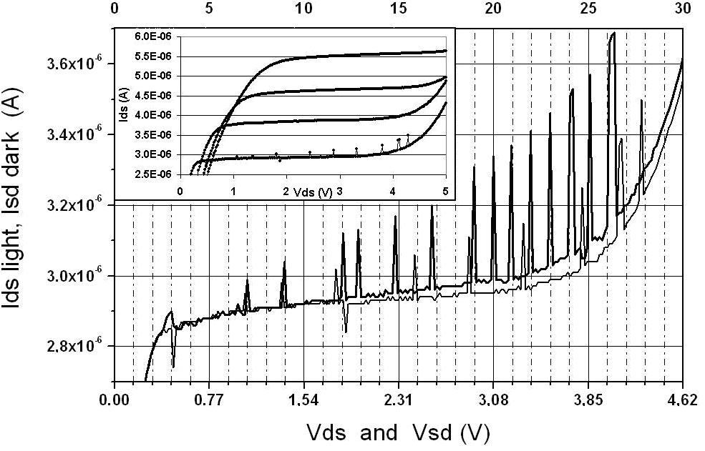

Figure 3. Top insert: Ids output curves at Vg of 2, 3, 4, and 5V after dividing Ids by 1, 7, 16.5, and 27, respectively. Main figure: Expanded output of Ids in insert at a Vg of 2V on device #8 on wafer 74 at 300K showing Ids flowing along <110> direction from drain D to source S with grounded S, along with Isd flowing from S to D. The integers at the top are the allowed energy positions of a parabolically confined nanowire (6). See text to explain the 0.154V scale across the bottom.

Figure 4. Transfer curves of device #8 at several values of Vds with 4 small bumps between 1.72 to 2.02V, but only very small bumps outside of this range. Also note the dip at Vg of 1.8V in Vds of 0.1V, as well as the multi-valued quantized values of Vds at Vg of 2V, and also in Fig. 5 at the same Vg of 2V.

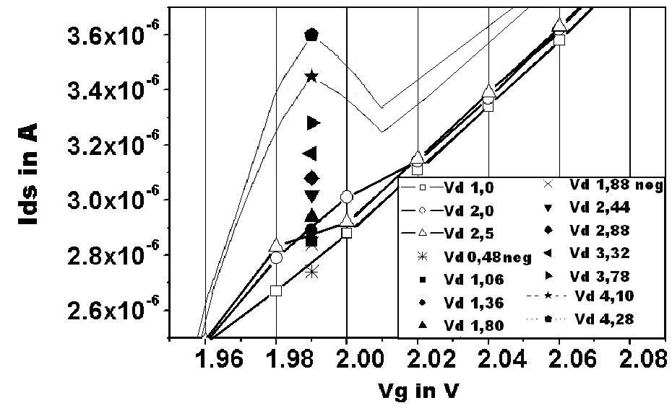

Figure 5. Expanded fourth bump of transfer curves from Fig. 4 and simulated maxima of the envelope of current spikes in Ids from Fig. 3 at Vg of 2V. These simulated data points are shifted to 1.99V to avoid overlap with open symbols at a Vg of 2V. See text. Also note that all of the Vd values in the tables in both Figs. 4 and 5 are actually Vds.

The images in Fig. 1 and 2 (8,10) from Baski’s group contain important structural clues regarding the origin of the spikes in Fig. 3. We have added two straight lines perpendicular to the atomic row <110> surface direction to schematically represent the edges of S and D of our large nMOSFET. These two lines are not absolutely straight due to our optical lithographic line edge roughness of several tens of nm, but this is not critical since it is the local distance between the edge of D and the nearest segments of the misalignment steps that must have specific resonant separations. These two figures also contain important information from Seo’s group. For example, the symbol c in Fig. 2 shows one of several unusual curved step segments that have been identified as (6 9 17) orientations (20). The [113] and/or the local step face of the curved (6 9 17) steps, along with the possible Schottky rectifying barriers at the Al metal overlay on the n+ poly-Si contact edge of D, are proposed to be responsible for the electron reflections at opposite ends of the active q-dot resonant cavities (17). The important aspect of Fig. 1 for our purposes is thought to be the first narrow white ridge below each arrow. This pi-bonded chain is bordered by two rows of gray T atoms that have tetramer-bonding (21). The pi-chain is of particular interest because localized Scanning Tunneling Spectroscopy (STS) measurements have very recently shown that the empty-state onset of the pi-chain is 0.5 eV smaller than that of the other white ridges (honeycomb-bonded chains) on each side of the pi-chains (22). Seo suggested that the pi-chain and perhaps one or both of the T-rows, which have a total width near 2 nm, are the likely atomic ridges to explain how electrons enter and traverse the Si NWs (23). We note that this argument is based on STM/STS data taken on pristine Si in UHV and the actual surface is covered by thermally grown SiO₂ which should cause some repositioning of the interface atoms.

Summary of Our Working Model and an Applications Note.

Our spikes are thought to be caused by many parallel NWs between S and D, some fraction of which are terminated at special electron-reflecting portions of misalignment steps of Fig. 2 by q-dots in contact with the edge of D. Electrons flow ballistically across many steps of Fig. 2, feed and charge up the q-dots nearest D, thereby causing coulomb blockade for the NW/q-dot combination. The stored electrons block the spike current until specific resonant Vds or Vsd voltages are applied, at which time the excited electrons are ejected into D to cause a spike. The NWs and q-dots are parabolically confined in oxide on the top sides and the bottom sides are in intimate contact with the underlying bulk Si. The NWs and q-dots appear to be partially isolated from the underlying inversion layer by the 1 to 2 nm wide interface-depleted zone (14). The negative spikes are thought to be due to Kronig-Penney electron reflections or perhaps to hole transmittances (6). Some potential applications for SPIKEMOS are listed in (24).

Acknowledgements
We are heavily indebted to the research groups of Alison A. Baski of Virginia Commonwealth University in Richmond,VA and Jae M. Seo of Chonbuk University in Korea for sharing their extensive STM and STS high-index silicon data. We also had fruitful interactions with L. Lester, P. Eliseev, K. Malloy, R. Devine, and ex-students S. R. Sheu, C. Matzke, and Q. Wang of CHTM/UNM, Thomas Digges Jr. at VSI in Fredericksburg, VA, and Jamal Deen at McMasters University of Hamilton, Ont. Canada.
The work was partially supported by CONACyT-Mexico under grants 39886 and 47141.

References

- C. Day, Physics Today, p. 19 for zero-magnetic-field spin effects, January (2008), and see important cited references. For high-magnetic-field spin effects up to 7 Tesla, see: O. M. Auslaender, H. Steinberg, A Yacoby, Y. Tserkovnyak, B. I. Halperin, K. W. Baldwin, L. N. Pfeiffer, K. W. West, Science, 308, 88 (2005).
- E. R. Bittner, J. G. S. Ramon, S. Karabunarliev, J. Chem. Phys. 122, 214719 (2005).
- S. Hoogland, Photonics Spectra, pp.80-86, January (2008).
- J. Gabelli, G. Feve, J.-M. Berroir, B. Placais, A. Cavanna, B. Etienne, Y. Jin, D. C. Glattli, Science, 313, 499 (2006).
- M. C. Tringides, M. Jatochowski, E. Bauer, Physics Today, p. 50. April (2007).
- J. P. McKelvey, Solid State and Semiconductor Physics, p. 99 parabolic potential well, p. 216 Kronig-Penney model, Harper and Row, New York (1966).
- S. Tarucha, D. G. Austing, T. Honda, R. J. van der Hage, L. P. Kouwenhoven, Phys. Rev. Lett, 77, 3613 (1996). For parabolic confinement effects: P. Matagne, J. P. Leburton, D. G. Austing, S. Tarucha, Phys. Rev. B, 65, 085325 (2002).
- A. A. Baski, S. C. Erwin, L. J. Whitman, Surface Sci., 392, 69 (1997). Also A. A. Baski, S. C. Erwin, L. J. Whitman, Science, 269, 1556 (1995).
- D. L. Kendall, M. Kendall NSTI-Nanotech, Boston, 3, 510 (2004); Also all authors of present paper, Mex. Congress AVS, Zacatecas, MX, (2004), Abstracts PLE-0-4 and MIC-6-12. Access at http://www.starmega.com/publications.htm .
- A. A. Baski, Mex. Congress AVS, Vera Cruz, MX (2002). Power Point foil published with the permission of A. A. Baski. We have added labels and white lines to help explain our working device model, as discussed in the text.
- M. Castro, F. J. De la Hidalga, P. Rosales, A. Torres, W. Calleja, E. A. Gutierrez, D. L. Kendall, ECS Transactions, 6(13), 21 (2007) Mobilities; also ECS Transactions, 6(13), 29 (2007) Implantations. Access at website in (9).
- R. R. Rodriquez, W. Calleja, F. J. De la Hidalga, P. Rosales, A. Torres, D. L. Kendall, ECS Transactions, 3(33), 9 (2007) Oxide growth; Abstract 0986 ECS Cancun, Charge state densities, ECS Mtg. Cancun (2006). Access website in (9).
- T. Cole, A. A. Lakhani, P. J. Stiles, Phys. Rev. Lett. 38, 722 (1977).
- T. Ando, A. B. Fowler, F. Stern, Rev. Mod. Phys. 54, 437-672 (1982), p. 575 for a critical device discussion of (13); p. 475 for electron depleted interface diagram.
- S. B. Field, M. A. Kastner, l. U. Meirav, J. H. V. Scott-Thomas, D. A. Antoniadis, H. I. Smith, S. J. Wind, Phys. Rev. B 42, 3523 (1990).
- J. P. Colinge, W. Xiong, C. R. Cleavelin, T. Schulz, K. Schrufer, K. Matthews, P. Patruno, Elect. Dev. Lett., 27, 775 (2006).
- We are still studying hot electron damage effects, deep subthreshold transfer curves at 300K on wafer 73 and a different type of output spikes, anomalous subthreshold transfer curves from 77 to 300K, a proposed linear energy band diagram for the spike part of the output characteristics at 300K, and the effect of parabolic confinement on the magic number sequences in both Ids and Isd.
- J. Wang, A. Rahman, A. Ghosh, G. Klimeck, M. Lundstrom, IEEE Trans. ED-52, 1589 (2005). Also, Y. Zheng, C. Rivas, R. Lake, K. Alam, T. B. Boykin, G. Klimeck, IEEE Trans. ED-52, 1097 (2005).
- P. Richman, MOS Field-Effect Transistors and ICs, p. 90, J. Wiley, New York, (1973).
- Y. Z. Zhu, H. Kim, J. M. Seo, Phys. Rev. B, 73, 245319 (2006).
- H. Kim, H. Li, Y. Z. Zhu, J. R. Hahn, J. M. Seo, Surface Sci., 601, 1831 (2007).
- H. Kim, H. Li, G. Duvjir, J. M. Seo, AVS Meeting, Abs. SS-ThP6, Seattle (2007).
- J. M. Seo, private communication with the first author.
- Applications for our ordered spikes include base-16 logic in the space of a single MOSFET, multi-frequency wireless, and precise V-standards from 0.154V to 4.004V. Access biological and other applications of Strongly Textured Atomic Ridges (STAR) in the Mexican AVS Abstract PLE-0-4 of the website in (9).

